ASSIGNMENT – 1

INTERNSHIP

NAME: HIRTHICK ROSHAN R

USN: 22BTRCL066

SEC: AIML- C

1. Create a Python script that takes a student's score (0-100) as input and prints their grade based on the following criteria:

Above 90: "Grade: A"

80 to 90: "Grade: B"

70 to 79: "Grade: C"

60 to 69: "Grade: D"

Below 60: "Grade: F"

ANSWER:

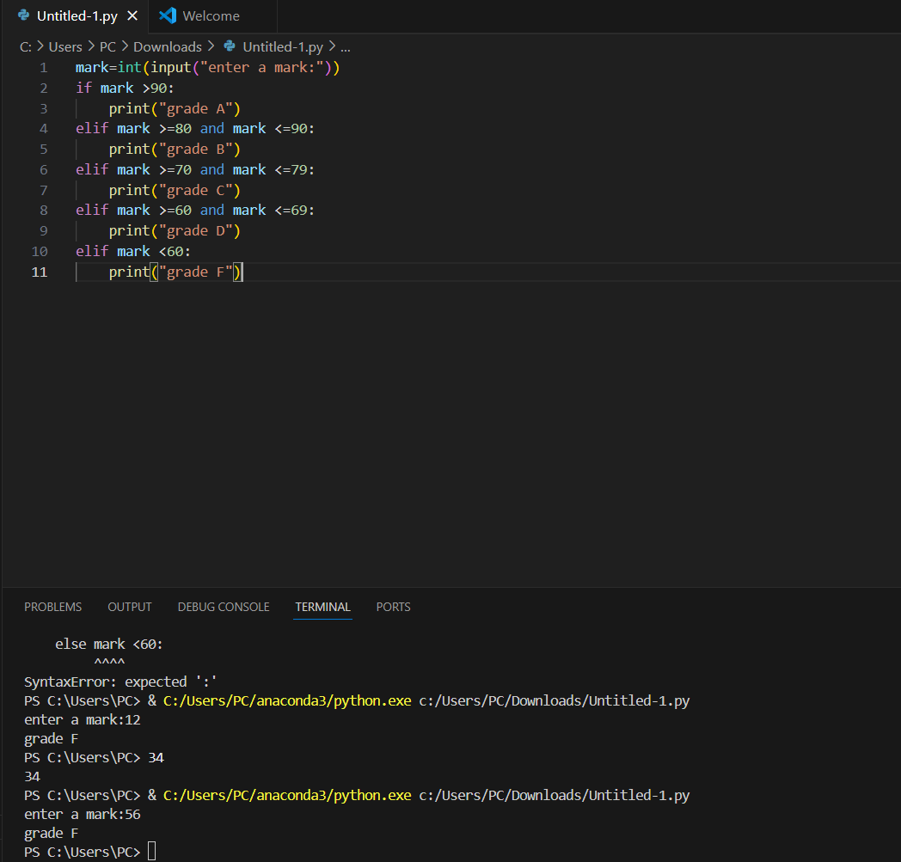

2. Create a Python program that applies a discount to a purchase based on the amount spent. The program asks for the total amount and applies the following discount rates:

Spend over $500: 20% discount

Spend $200 - $500: 10% discount

Spend below $200: No discount

The program should print the original amount, the discount applied, and the final amount after the discount

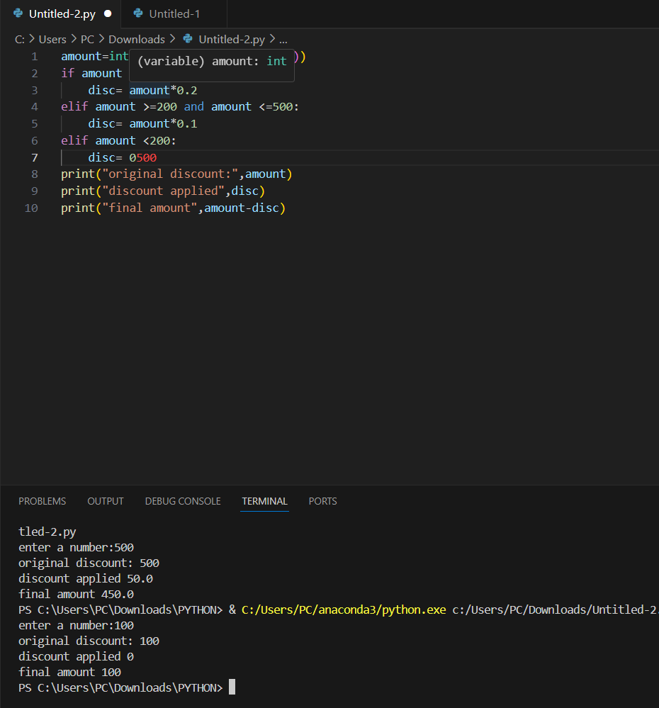

3. Create a program that asks for the user's birth month and day and then tells them their zodiac

sign. For simplicity, you can use the following date ranges:

Aries: March 21 - April 19

Taurus: April 20 - May 20

Gemini: May 21 - June 20

Cancer: June 21 - July 22

Leo: July 23 - August 22

Virgo: August 23 - September 22

Libra: September 23 - October 22

Scorpio: October 23 - November 21

Sagittarius: November 22 - December 21

Capricorn: December 22 - January 19

Aquarius: January 20 - February 18

Pisces: February 19 - March 20

Make sure to handle invalid inputs gracefully.

ANSWER:

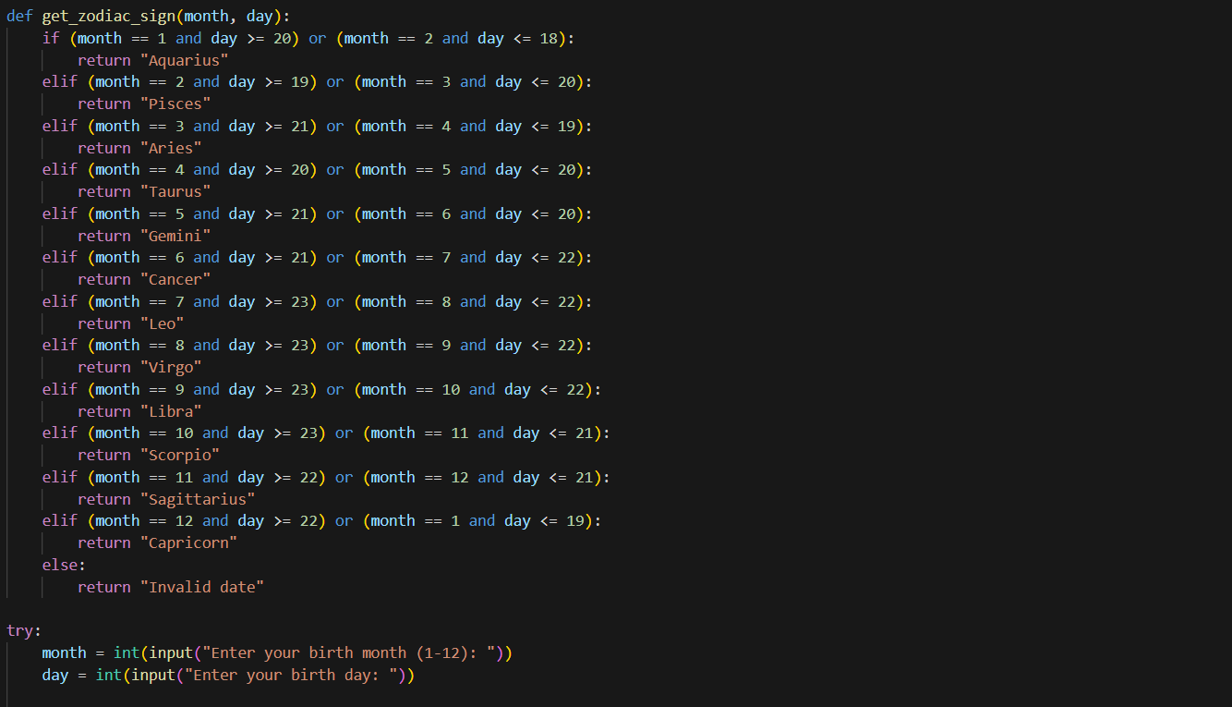

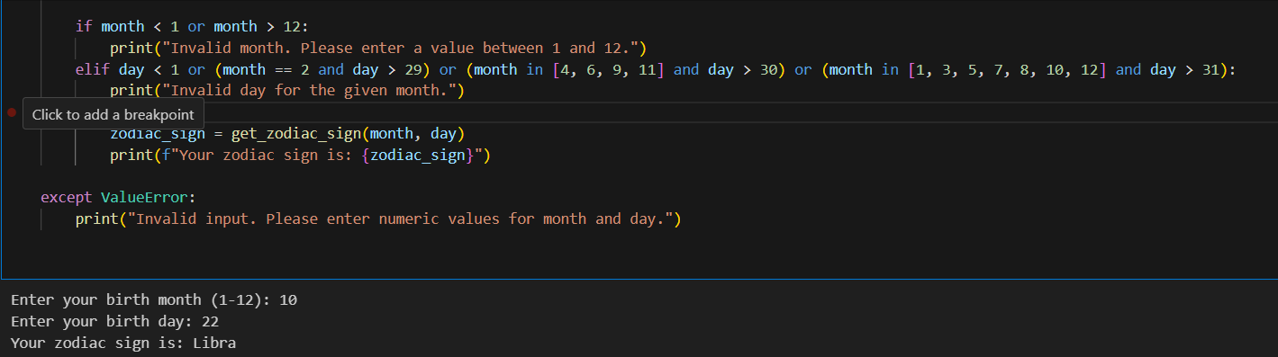

4. Write a Python program to check the validity of a password entered by the user. The password

is considered valid if it meets the following criteria:

At least 1 letter between [a-z] and 1 letter between [A-Z].

At least 1 number between [0-9].

At least 1 character from [$#@].

Minimum length of 6 characters.

Maximum length of 16 characters.

The program should print whether the password is valid or not based on these criteria.

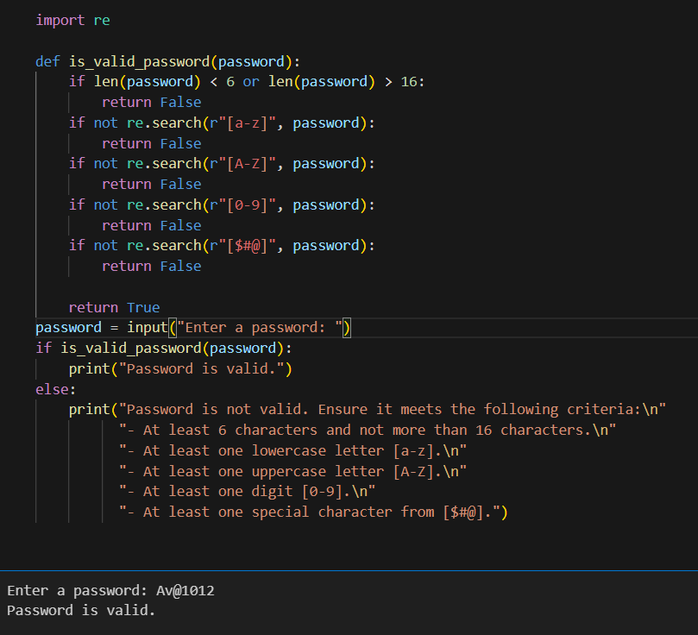

5. Implement a simple number guessing game. First, set a target number within a certain range

(e.g., 1 to 100). Then, using a while loop, ask the user to guess the number. Provide feedback for

each guess ("too high" or "too low"). The game ends when the user guesses the number

correctly. Use a break statement to exit the loop once the correct number is guessed

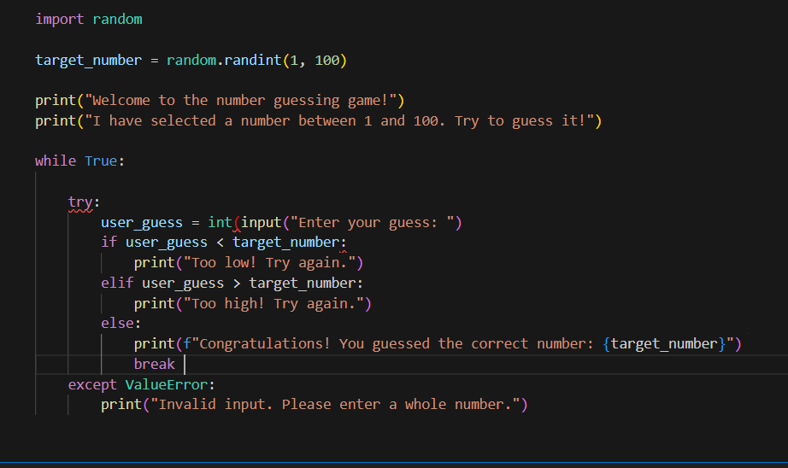

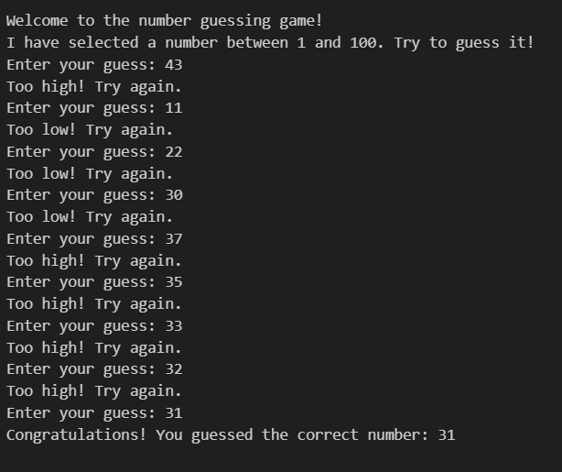

6. Write a Python program that asks the user to enter a range (start and end numbers). Use a for

loop to iterate through this range, and for each number, check if it is a prime number. If it is,

print the number. Use the continue statement to skip non-prime numbers efficiently.

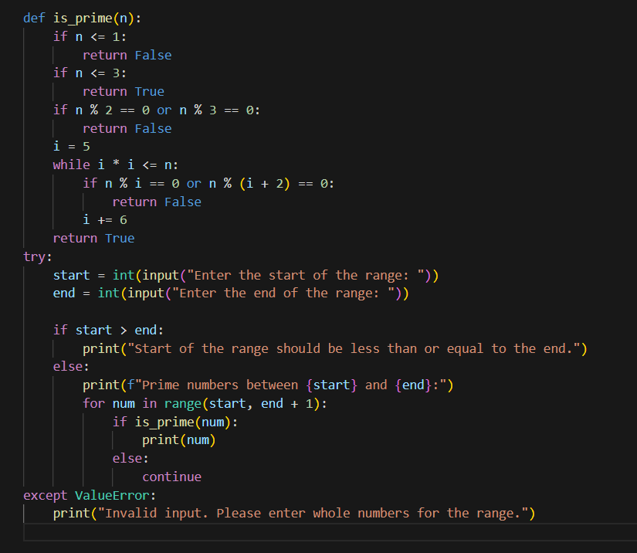

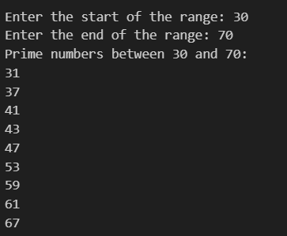

7. Create a Python program that iterates through a list of numbers (you can define the list in the

code) and calculates the sum of the numbers. However, if the program encounters a number

that is negative, it should stop adding any further numbers (i.e., break out of the loop) and print

the current sum up to that point.

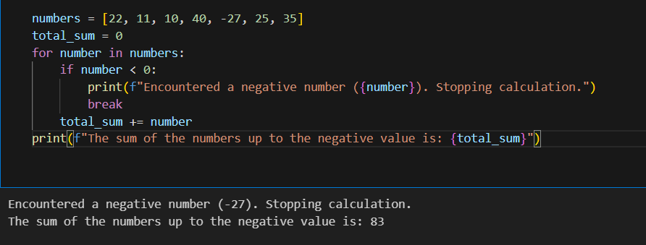

8. Write a Python program to print the following patterns

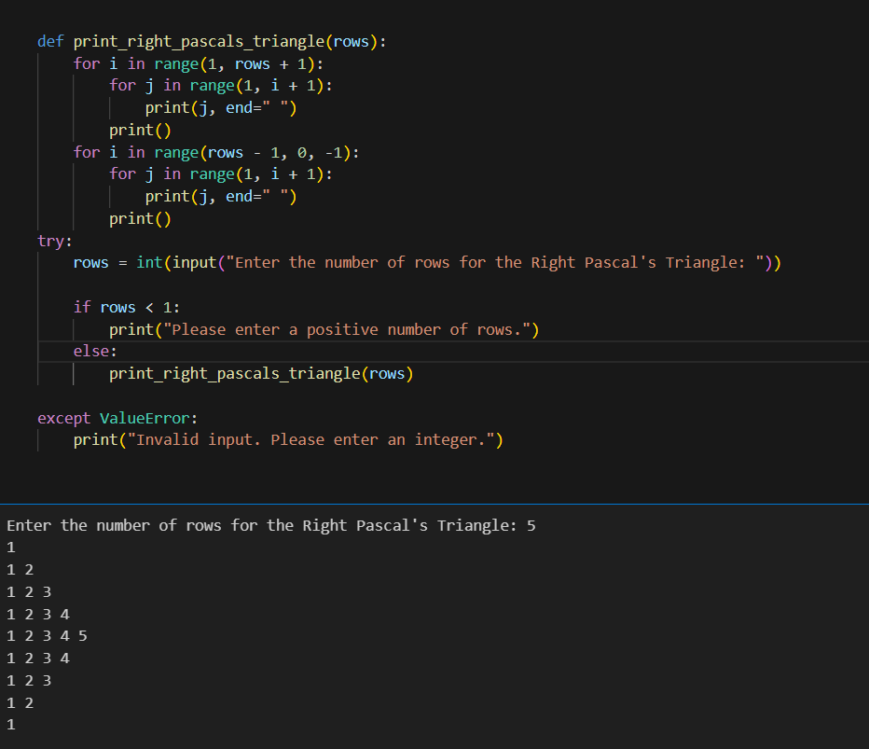

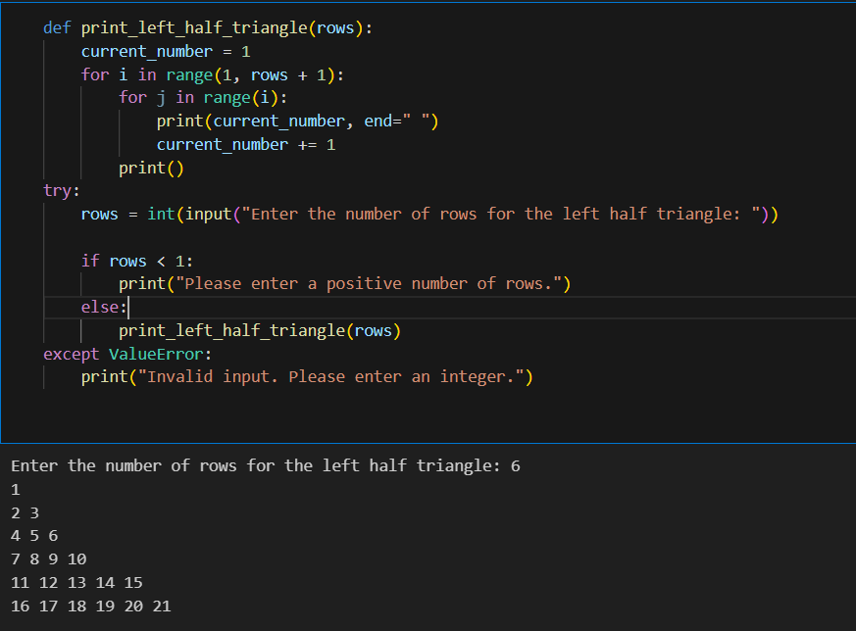

9. Create a program that asks for two numbers and prints all the numbers between them that are

divisible by a third number asked from the user.

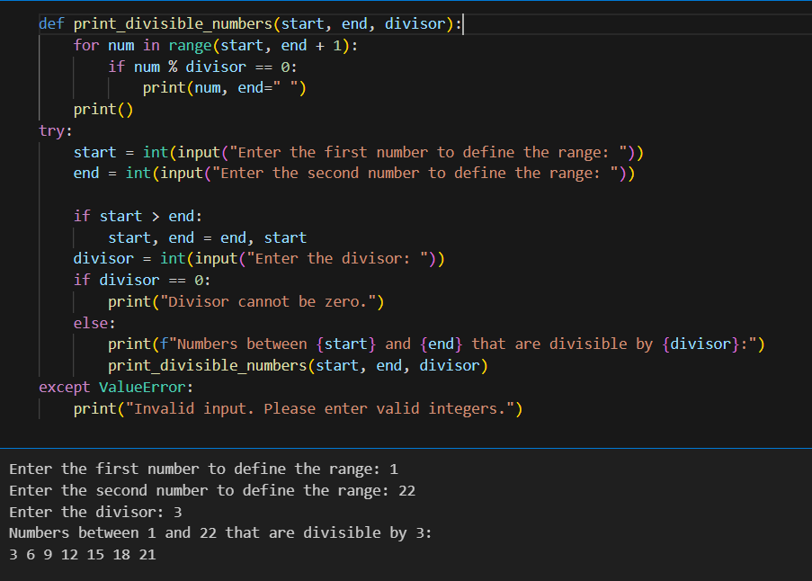

10. Write a recursive function named reverse_string that takes a string as input and returns

its reverse. The function must use recursion to accomplish this task and should not use

any loops or slicing ([::-1]).

Example Usage:

print(reverse_string("hello"))

Expected Output:

"olleh"

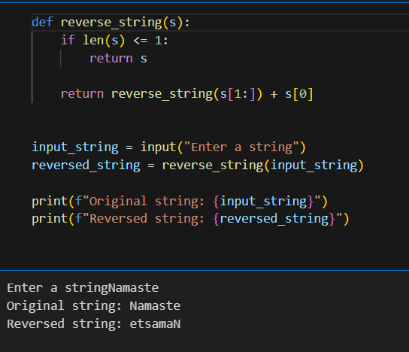

11.Create a function longest_word(sentence) that finds and returns the longest word in the

given string sentence. If there are multiple words of the same length, return the first one

encountered.

# Example: longest_word("I love programming") should return "programming"

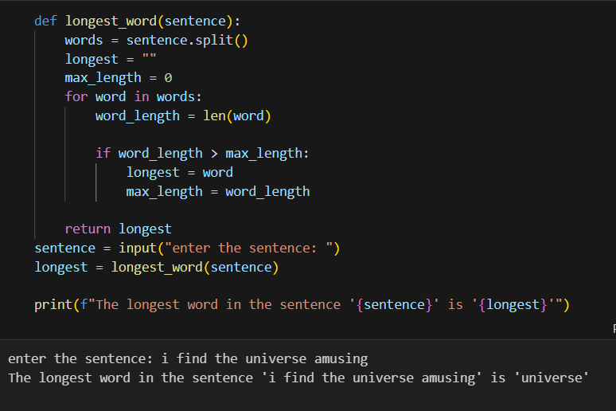

12. Create a Python function named custom_sort that takes a list of tuples where each tuple

contains a name and a score. The function should return a new list sorted by scores in

descending order. If two tuples have the same score, they should be sorted

alphabetically by name in ascending order. Test your function with a predefined list of

tuples and print the sorted list.

Sample Input: [('Alice', 88), ('Bob', 95), ('Charlie', 88), ('Dave', 95)]

Sample Output: [('Bob', 95), ('Dave', 95), ('Alice', 88), ('Charlie', 88)]

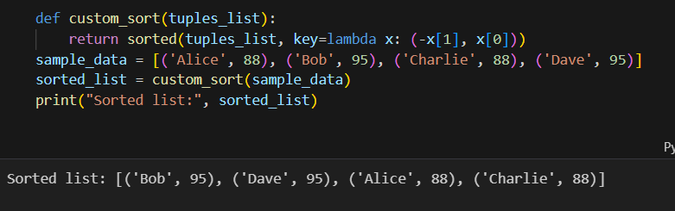

13. Develop a Python function named transform_string that takes a string and performs the

following transformations: it capitalizes every other letter starting with the first character

(ignoring non-letter characters for the alternation pattern), and it replaces spaces with

hyphens (-). For example, hello world becomes HeLlO-WoRlD. After defining the

function, ask the user for a string and print its transformation.

Sample Input: hello world

Sample Output: HeLlO-WoRlD

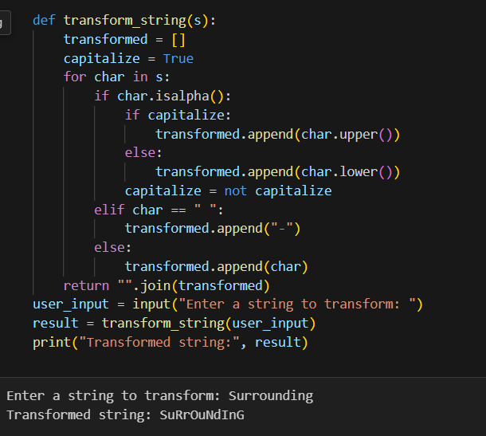

14. Create a function named simulate_file_renaming that takes two parameters: a list of

filenames (as strings) and a new name template (a string containing a placeholder for a

number, e.g., image_##). The function should return a list of strings representing the

new filenames where the placeholder is replaced by an incremental number, starting

from 1 and formatted to have leading zeros if necessary, according to the placeholder's

length. For instance, renaming ['a.jpg', 'b.jpg', 'c.jpg'] with the template photo_### would

result in ['photo_001.jpg', 'photo_002.jpg', 'photo_003.jpg']. This exercise simulates the

renaming process, so you should only return the renamed list without actually renaming

any files.

Sample Input: ['a.jpg', 'b.jpg', 'c.jpg'], photo_###

Sample Output: ['photo_001.jpg', 'photo_002.jpg', 'photo_003.jpg']

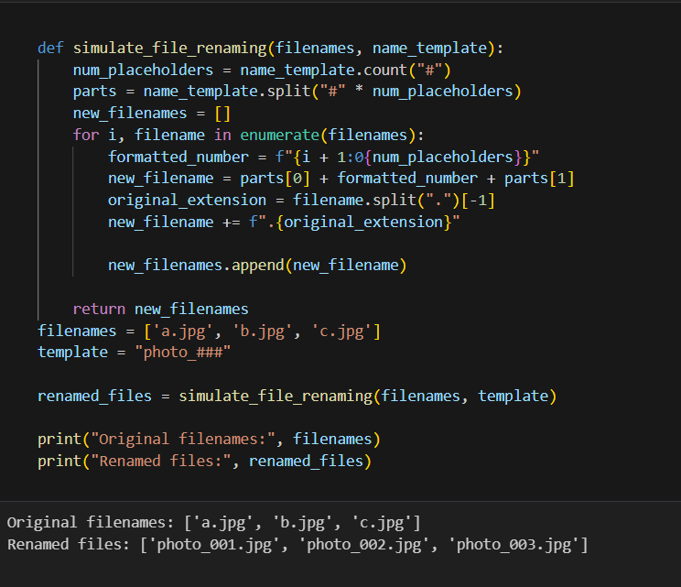

15. You are given a list of words. Write a Python function called group_anagrams that groups all

anagrams together and returns them as a list of lists.

Two words are considered anagrams if they contain the same characters but in a different order.

Examples:

Input: ["eat", "tea", "tan", "ate", "nat", "bat"]

Output: [["eat", "tea", "ate"], ["tan", "nat"], ["bat"]]

Input: ["listen", "silent", "top", "pot", "hello", "world"]

Output: [["listen", "silent"], ["top", "pot"], ["hello"], ["world"]]

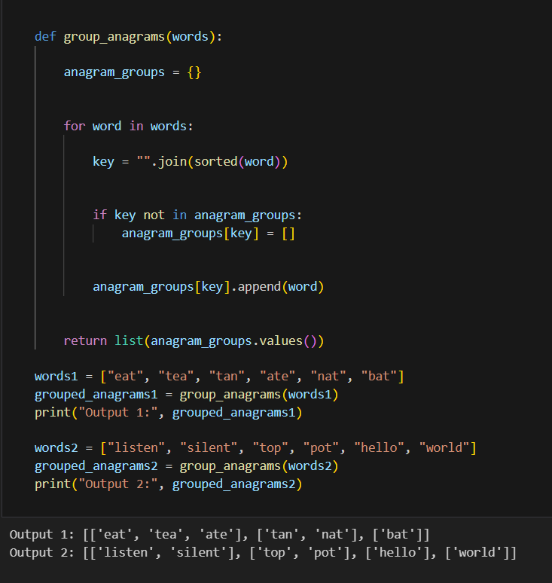

16. You are given a list of integers. Write a Python function called max_subarray_sum to find the

contiguous subarray within the list that has the largest sum and return that sum.

For example, given the list [−2, 1, −3, 4, −1, 2, 1, −5, 4], the contiguous subarray with the largest

sum is [4, −1, 2, 1], and the maximum sum is 6.

Examples:

Input: [-2, 1, -3, 4, -1, 2, 1, -5, 4]

Output: 6 (corresponding to the subarray [4, -1, 2, 1])

Input: [1, 2, 3, 4, 5]

Output: 15 (corresponding to the subarray [1, 2, 3, 4, 5])

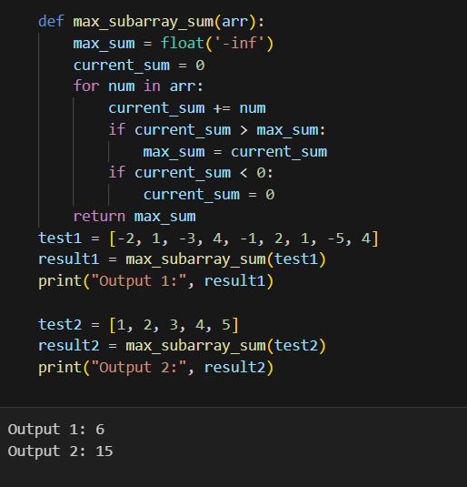

17. Implement a function that performs a sequential search through a list for a specified target value.

The function should return the index of the target if found, and -1 if the target is not in the list.

Sample Input: ([5, 3, 7, 1, 9], 7)

Sample Output: 2

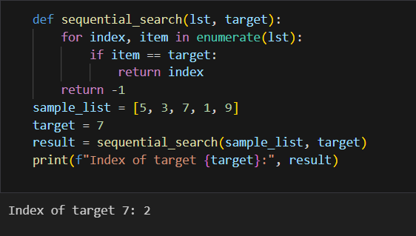

18. Design a method to encode a list of strings to a single string and another method to decode it

back to a list of strings.

The encoded string should be concise and easily decodable. Assume there are no character

restrictions for individual strings.

Examples:

19. Input: ["hello", "world"]

Encoded Output: "5#hello5#world" (or another unique format of your choice)

Decoded Output: ["hello", "world"]

20. Input: ["abc", "def", "ghi"]

Encoded Output: "3#abc3#def3#ghi"

Decoded Output: ["abc", "def", "ghi"]

